*Figure 1. Canker healing scoring system used in Live Soil Amendment (a) and Endophyte Inoculation Experiments (b) which employed 6-mm plug (a) and spore suspension (b) inoculations, respectively.*

1. *Canker healing scale for plug inoculations in Live Soil Amendment Experiment (sapwood shown): 0), no raised reactive sapwood border around canker margin; 1), raised boundary around canker margin without covering original wound; 2), wound partly covered by reactive tissue; 3), wound is completely healed.*
2. *Canker healing scale for spore suspension inoculations in Endophyte Inoculation Experiment (outer bark shown unless otherwise indicated): 0), no raised reactive sapwood border around canker margin (a) sapwood and (b) outer bark shown; 1), raised boundary around canker margin without covering original wound (sapwood shown); 2), wound partly covered by reactive tissue; 3), sides of wound closed but not joined by new tissue; 4), sides of closed wound joined by formation of healing scar.*

|  |  |
| --- | --- |
| **(a)** | **(b)** |

Figure 2. Necrotic area (a) and healing of cankers (b) caused by G. morbida in seedlings that received forest, plantation, and steam-treated soil amendments. Different letters in plot (a) denote significant Tukey-adjusted contrasts from a Box-Cox (λ = 0.9) transformed linear model. Outliers not shown. Different letters in plot (b) denote significant unadjusted contrasts from a log-link proportional odds model.



Figure 3. Relative abundance of UNITE database fungal order assignments of culturable endophyte OTUs based on internal transcribed spacer (ITS) sequences from roots of seedlings grown in potting mix amended with steam-treated, plantation, and forest soil and inoculated with G. morbida or agar (Sham).

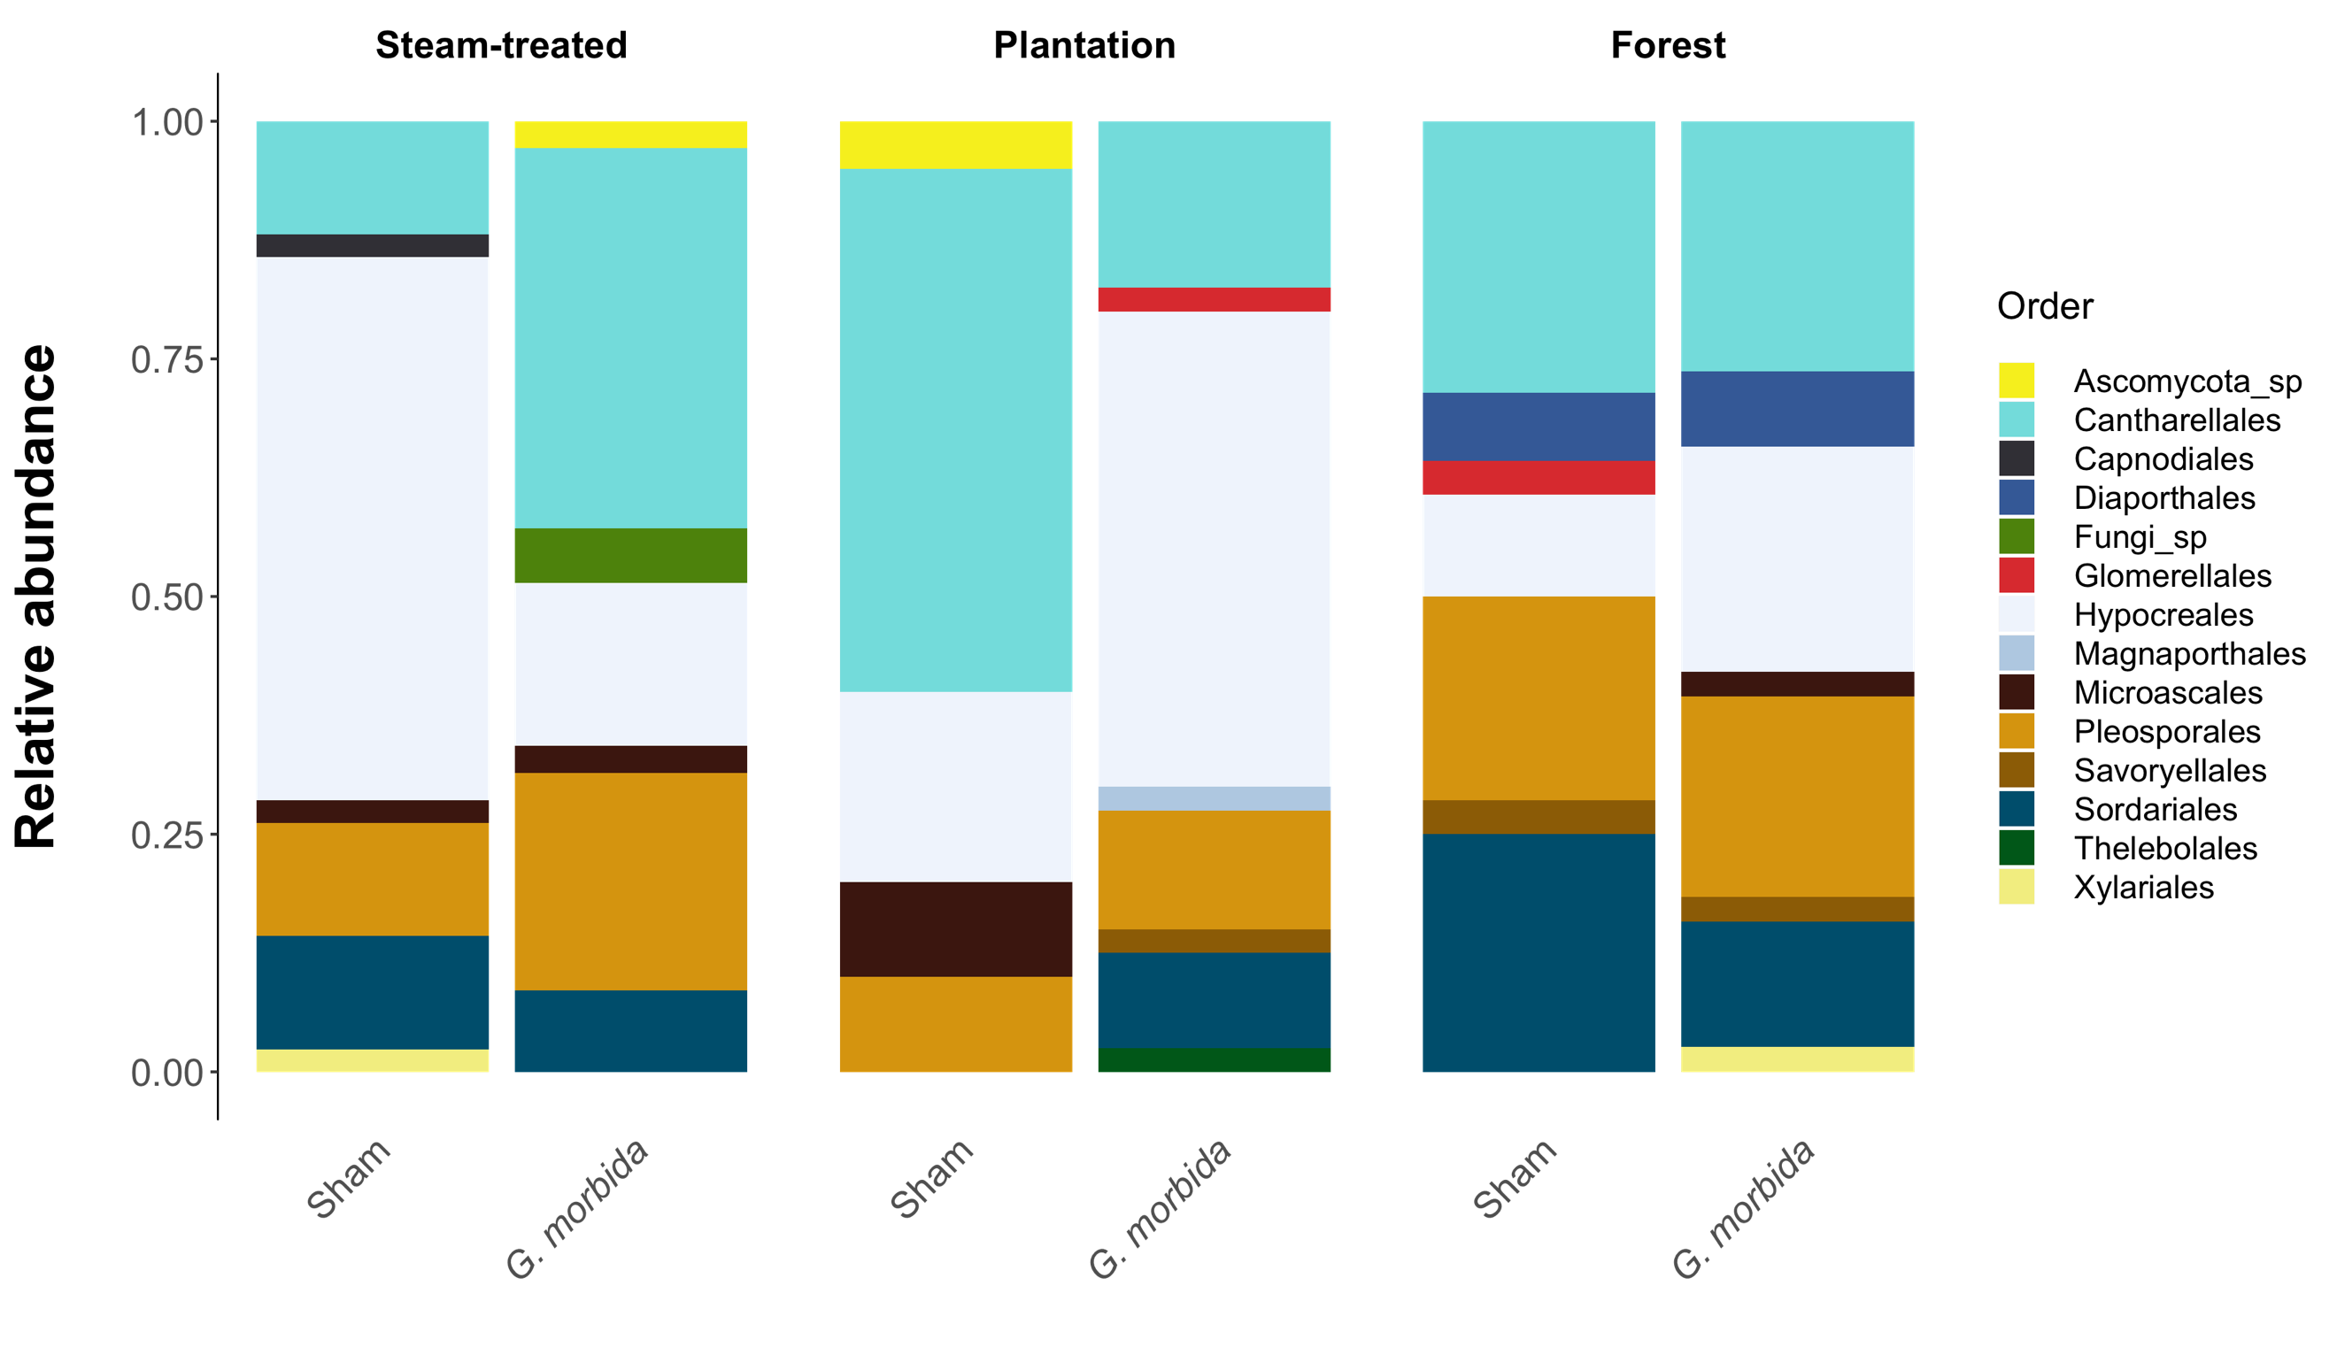

Figure 4. Isolation rates (Mean ± overdispersion adjusted SE number of colonies per plant) of (a) Fusarium spp. and (b) Rhizoctonia spp. from roots of walnut seedlings after being amended with steam-treated, plantation, and forest soil and inoculated with Geosmithia morbida or agar (Sham).



Figure 5. Necrotic area (a) and healing of cankers (b) caused by G. morbida in seedlings grown in untreated potting mix (Non-sterile) or inoculated with filtrate only (Control), Trichoderma asperellum (Rh-366), FSSC sp. (Rh-217), or both Rh-366 and Rh-217 together (FSSC + Trich). Different letters in plot (a) denote significant Tukey-adjusted contrasts from a Box-Cox (λ = 0.4) transformed linear model. Outliers denoted by open circles were not included in model. Different letters in plot (b) denote significant unadjusted contrasts from a log-link proportional odds model.

